RESTAURANT ORDER MANAGEMENT SYSTEM
MEMBER 4 – COMPLETE DESIGN DOCUMENT
Cart Management, Checkout, System Design and Interface Design

SCOPE AND DESIGN ASSUMPTIONS
This document covers the ten requested Member 4 deliverables in the exact order provided: functional description, ordering process, Manage Cart use case, Checkout use case, Class Diagram, ERD, table descriptions and keys, Cart GUI, Checkout GUI, and interface descriptions.
The diagrams and screen layouts are proposed designs based on the stated project scope. The group should confirm the supported fulfillment modes (for example, dine-in, takeaway, or delivery), payment methods, login policy, taxes, discounts, and optional customer fields before implementation. Illustrative sample prices and dish names in the GUI are placeholders, not actual restaurant data.

1. FUNCTIONAL DESCRIPTION – CHOOSE AND ORDER DISHES
Purpose: This function allows customers to view dish information, select dishes, add them to a cart, update their selections, and proceed to checkout.
Target Actors: Customer (guest or registered member, subject to the project's authentication design).

1.1 View Dish Information
The customer selects a dish from the menu. The system displays available details such as dish name, image (if available), description, price, and availability status. The system must clearly identify dishes that cannot currently be ordered.

1.2 Add Dish to Cart
The customer chooses an available dish, specifies a positive whole-number quantity, and selects Add to Cart. The system validates the dish and quantity. If the dish already exists in the active cart, the system may increase its quantity; otherwise, it creates a new cart item. The cart totals are recalculated and the updated cart is displayed.

1.3 Update Cart
The customer can increase or decrease item quantities, remove items, and review each dish's unit price and line subtotal. Every change triggers recalculation. A zero quantity is treated as removal; negative quantities are rejected.

1.4 Proceed to Checkout
The customer selects Proceed to Checkout. The system checks that the cart contains at least one valid item, then revalidates dish availability and current prices before moving to checkout. If the cart is empty or an item is no longer available, the system displays a clear message and asks the customer to update the cart.

1.5 Business Rules
- Only dishes marked Available can be added to the cart.
- Quantity must be a positive whole number.
- Line subtotal = unit price × quantity.
- Cart subtotal = sum of all valid cart-item line subtotals.
- The system recalculates totals after every cart modification.
- Checkout cannot proceed with an empty cart.
- Dish availability and price must be checked again before order confirmation.
- Any tax, discount, service charge, or delivery fee is applied only if included in the approved project requirements.

2. FUNCTIONAL DESCRIPTION – ORDERING PROCESS
Purpose: The ordering process converts the customer's validated cart into a confirmed order and records the order and payment information.

2.1 Process Steps
- Customer reviews the cart and chooses Proceed to Checkout.
- System verifies that the cart is not empty and that all selected dishes remain available.
- Customer logs in or registers if authentication is required by the project policy.
- Customer provides the required order information. Depending on the agreed scope, this may include name, phone number, email, table number, or fulfillment details.
- Customer reviews the order summary, quantities, prices, and total amount.
- Customer selects one of the payment methods supported by the implemented system.
- System validates all required information and recalculates the final amount.
- Customer confirms the order.
- System creates the order record and its order-item records. The order receives an initial status such as Pending or Confirmed according to the group's workflow.
- System records payment information and payment status. Sensitive payment credentials must not be stored in the restaurant database.
- System displays an order confirmation containing the order number, ordered items, total amount, and current order status.
- If email notification is implemented and a valid email address is available, the system may send an order confirmation email.
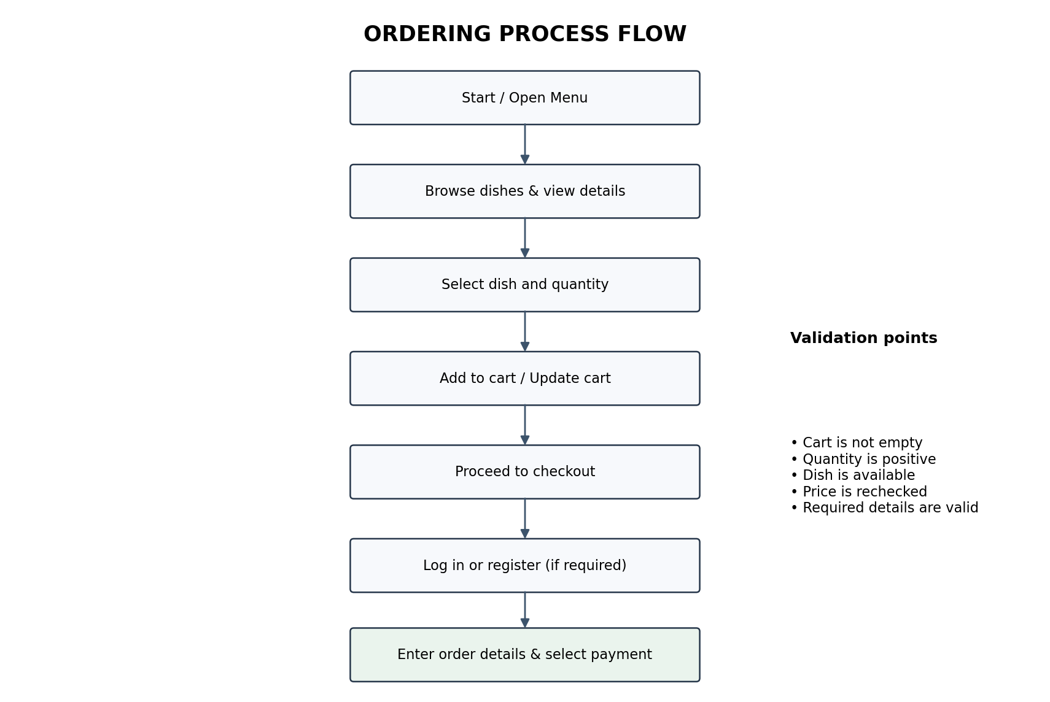

2.2 Exception Handling
- If the cart is empty, prevent checkout and direct the customer back to the menu.
- If a dish becomes unavailable, identify the affected item and require the customer to remove it or choose another dish.
- If a price changes before confirmation, show the updated price and ask the customer to review the new total.
- If required customer or order information is missing or invalid, highlight the relevant field and do not create the order.
- If payment fails, retain the order/payment state according to the agreed workflow and show a clear retry or alternative-payment message. Do not mark an unsuccessful payment as Paid.

3. USE CASE SPECIFICATION – MANAGE CART
Use Case ID | UC-01
Use Case Name | Manage Cart
Primary Actor | Customer
Goal | Review and maintain selected dishes before checkout.
Preconditions | The menu is accessible. The customer has selected at least one dish to add, or has an existing active cart.
Trigger | Customer opens the cart or chooses an action to modify cart contents.
Postconditions | The cart contains the latest valid items and quantities; totals are recalculated.
Main Success Scenario | 1. Customer opens the cart. 2. System displays cart items and totals. 3. Customer changes a quantity or removes an item. 4. System validates the action. 5. System updates the cart and recalculates totals. 6. System displays the updated cart.
Alternative Flows | A1: Invalid quantity – system rejects the value and displays a message. A2: Item unavailable – system flags the item and asks the customer to remove or replace it. A3: Cart becomes empty – system displays an empty-cart message and a link/action to return to the menu.
Business Rules | Quantity must be a positive integer. The cart subtotal is the sum of line subtotals. Checkout is available only when at least one valid item remains.

4. USE CASE SPECIFICATION – CHECKOUT
Use Case ID | UC-02
Use Case Name | Checkout
Primary Actor | Customer
Supporting Actors | Payment service (only if online payment is integrated); email service (only if email notification is implemented).
Goal | Submit a valid cart and create an order.
Preconditions | The cart contains at least one valid item. Required dishes are available. Customer identity/order details can be collected according to project policy.
Trigger | Customer selects Proceed to Checkout.
Postconditions | A new order and order items are stored. Payment status and order status are recorded. A confirmation is displayed.
Main Success Scenario | 1. Customer enters checkout. 2. System revalidates cart items and prices. 3. Customer signs in if required. 4. Customer enters required contact/table/fulfillment information. 5. System displays order summary and total. 6. Customer selects payment method. 7. Customer confirms. 8. System creates order and order-item records. 9. System records payment status. 10. System displays confirmation and optionally sends an email.
Alternative Flows | A1: Cart empty – return to cart/menu. A2: Dish unavailable or price changed – require cart review. A3: Invalid required information – show validation errors. A4: Payment unsuccessful – record failure/pending status and show an appropriate message; do not mark Paid.
Business Rules | The final amount must be recalculated on the server. The order must contain at least one order item. Payment status must reflect the actual payment result. Do not store card numbers, CVV, passwords, or other payment credentials.

5. CLASS DIAGRAM
The proposed class diagram models the core objects needed for cart management and checkout. It is a conceptual design; method names and attributes can be adjusted to match the team's implementation language and coding conventions.
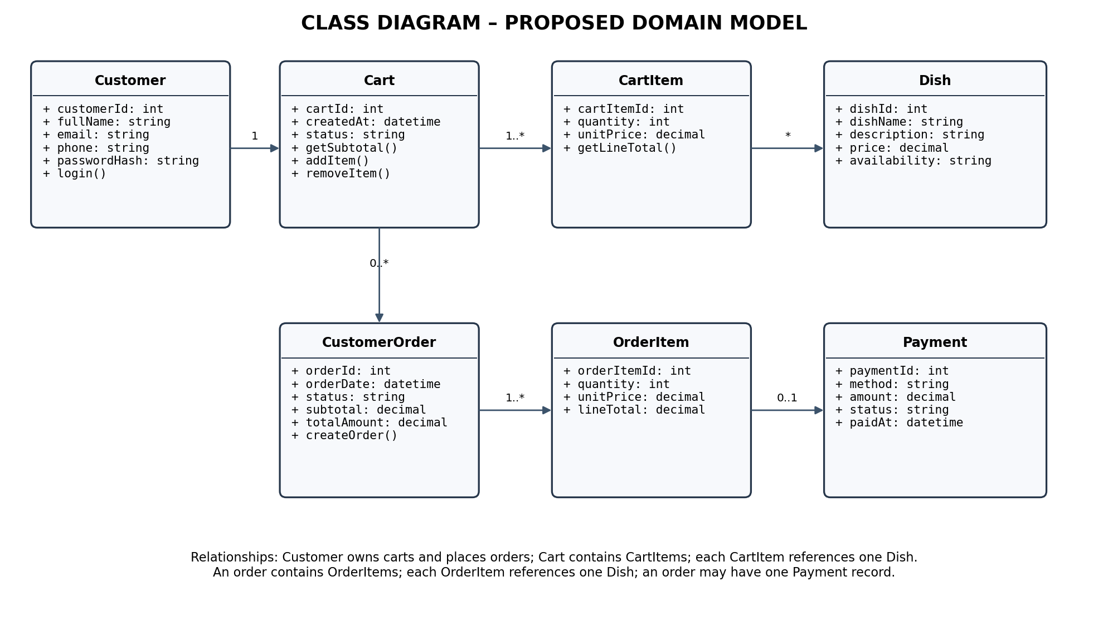

5.1 Class Responsibilities
- Customer: stores customer profile information and is associated with carts and orders.
- Cart: represents a customer's active selection and calculates the cart subtotal.
- CartItem: represents one dish and its selected quantity in a cart.
- Dish: stores menu information, price, and availability.
- CustomerOrder: stores the confirmed order header, date, status, and monetary totals.
- OrderItem: stores the dish, quantity, unit price, and line total captured for the order.
- Payment: stores payment method, amount, status, and payment timestamp; it does not store sensitive payment credentials.

6. ENTITY RELATIONSHIP DIAGRAM (ERD)
The proposed ERD maps the core classes into relational tables. Foreign-key relationships enforce referential integrity between customers, carts, dishes, orders, order items, and payments.
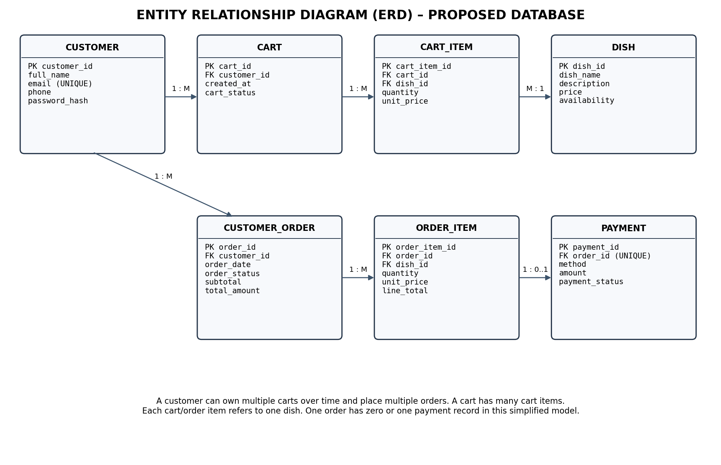

7. DATABASE TABLE DESCRIPTIONS, PRIMARY KEYS AND FOREIGN KEYS
Table | Purpose | Primary Key | Foreign Key(s) | Other Fields
CUSTOMER | Stores registered customer information. | customer_id (PK) | None | full_name, email (UNIQUE), phone, password_hash
DISH | Stores menu dishes and their current selling information. | dish_id (PK) | None | dish_name, description, price, availability
CART | Stores a customer's cart/session. | cart_id (PK) | customer_id (FK) → CUSTOMER.customer_id (nullable only if guest carts are supported) | created_at, cart_status
CART_ITEM | Stores individual dishes selected in a cart. | cart_item_id (PK) | cart_id (FK) → CART.cart_id; dish_id (FK) → DISH.dish_id | quantity, unit_price
CUSTOMER_ORDER | Stores the order header and customer/order totals. | order_id (PK) | customer_id (FK) → CUSTOMER.customer_id (nullable only if guest checkout is supported) | order_date, order_status, subtotal, total_amount
ORDER_ITEM | Stores each dish included in a confirmed order. | order_item_id (PK) | order_id (FK) → CUSTOMER_ORDER.order_id; dish_id (FK) → DISH.dish_id | quantity, unit_price, line_total
PAYMENT | Stores payment transaction status for an order. | payment_id (PK) | order_id (FK, UNIQUE) → CUSTOMER_ORDER.order_id | method, amount, payment_status, paid_at

7.1 Key and Data Integrity Rules
- Every table has a primary key that uniquely identifies each record.
- Foreign keys must reference an existing parent record, except where an explicitly permitted nullable relationship is used for guest checkout.
- Use DECIMAL (not floating-point) for prices and monetary amounts.
- Store the unit price in CART_ITEM and ORDER_ITEM so historical order totals do not change when a dish's current menu price changes.
- Use positive integer constraints for quantities and non-negative constraints for prices and totals.
- Use a UNIQUE constraint on CUSTOMER.email if email is the chosen unique login identifier.
- Use a UNIQUE constraint on PAYMENT.order_id in this simplified one-payment-record-per-order model. If the system supports multiple payment attempts, remove this uniqueness and model attempts separately.
- Store password hashes, never plain-text passwords. Do not store card numbers or CVV.
Note: The seven-table schema is intentionally focused on the requested cart and checkout scope. If the group requires restaurant tables, delivery addresses, discounts, menu categories, inventory, or multiple payment attempts, add the corresponding entities and relationships after confirming those requirements.

8. GUI DESIGN – SHOPPING CART
The following is a low-fidelity wireframe showing the main information hierarchy and controls for the cart screen. It is a design reference that can be recreated and styled in Figma.
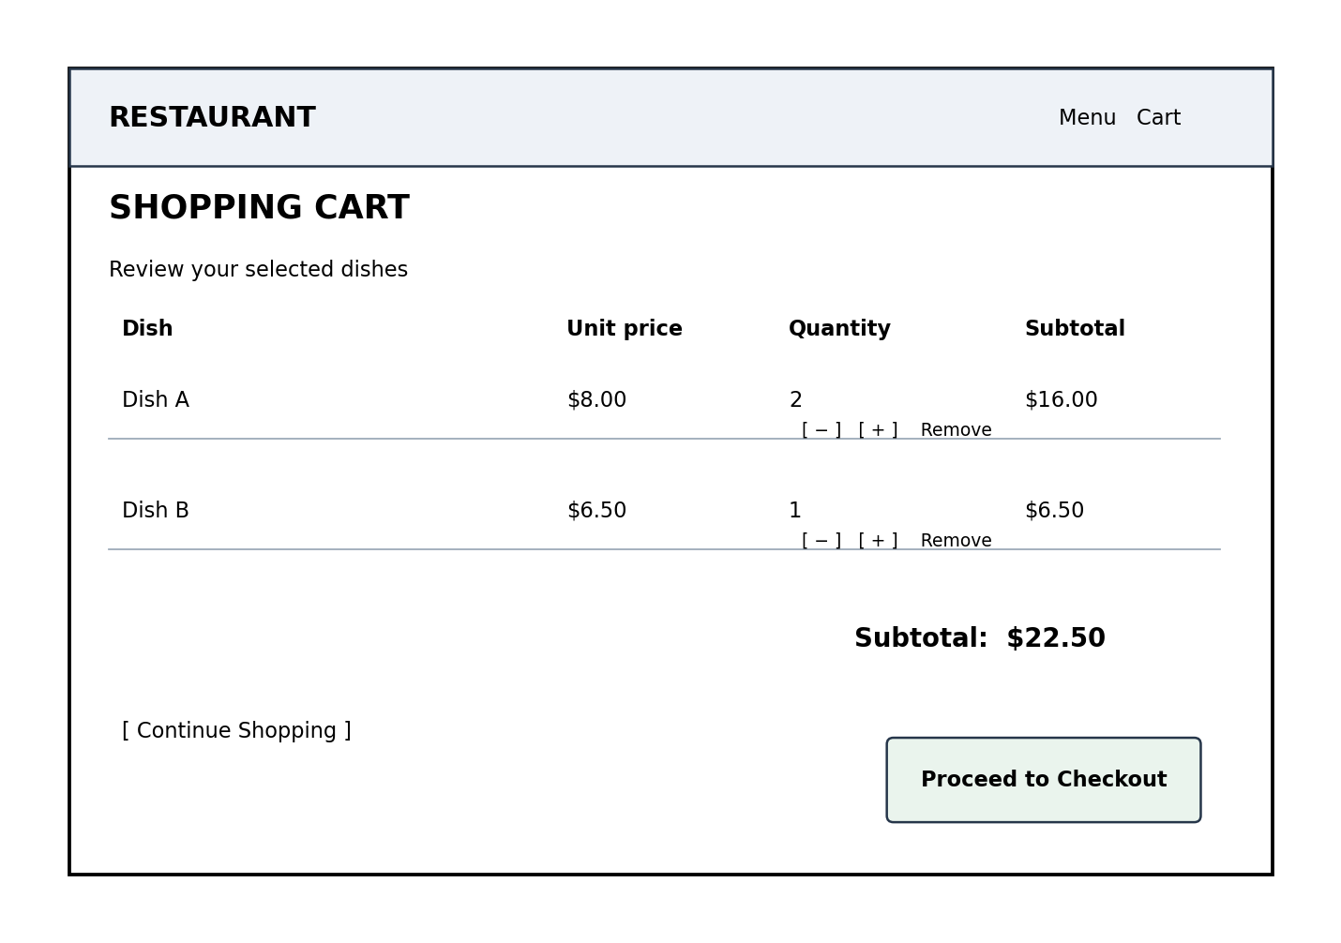

9. GUI DESIGN – CHECKOUT
The checkout wireframe groups customer/order information, payment selection, and the order summary. The exact fields should be adjusted to the confirmed order type and payment integrations.
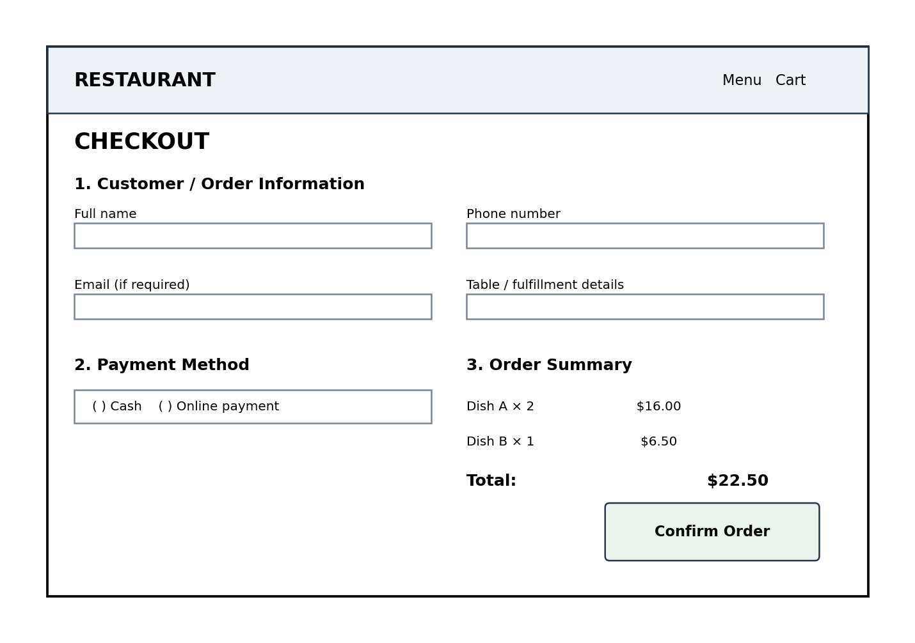

10. GUI DESCRIPTION

10.1 Shopping Cart Interface Description
- Header/navigation: displays the restaurant name or logo and navigation links such as Menu and Cart.
- Page title and guidance: identifies the page as the Shopping Cart and tells the customer to review selected dishes.
- Cart item list: each row displays dish name, unit price, quantity controls, and line subtotal.
- Quantity controls: plus and minus actions allow the customer to adjust the selected quantity. The interface should prevent invalid quantities.
- Remove action: allows the customer to delete an item from the cart.
- Cart summary: displays the subtotal and, only when applicable, separately lists taxes, discounts, service charges, or delivery fees.
- Continue Shopping: returns the customer to the menu without losing the current cart.
- Proceed to Checkout: opens the checkout page when the cart contains at least one valid item.
- Empty-cart state: when no items exist, show a clear message and an action to return to the menu.

10.2 Checkout Interface Description
- Header/navigation: maintains consistent branding and allows the customer to identify the current stage of ordering.
- Customer/order information: collects only the fields required by the agreed order flow, such as customer name, phone, email, table number, or fulfillment information.
- Payment method: displays only payment methods that are actually supported by the system. For example, Cash or Online Payment should appear only if implemented.
- Order summary: lists selected dishes, quantities, unit prices, line subtotals, and the final total.
- Validation feedback: identifies missing or invalid required information next to the relevant field.
- Confirm Order: submits the checkout request after all required information has been validated.
- Confirmation state: after successful order creation, displays the order number, items, amount, and order status. An email confirmation is shown as sent only if email integration is implemented and succeeds.

10.3 General Interface Requirements
- Use consistent typography, spacing, button styles, and navigation across the Cart and Checkout screens.
- Make prices and the final total easy to locate and read.
- Clearly distinguish primary actions from secondary actions.
- Provide understandable validation and error messages.
- Ensure the interface remains usable on common desktop and mobile screen sizes.
- Do not display sample placeholder prices or dish names in the final implementation.

FINAL REVIEW CHECKLIST
☐ Functional description covers viewing dishes, adding dishes, updating the cart, and proceeding to checkout.
☐ Ordering process includes validation, customer/order information, payment status, order creation, and confirmation.
☐ Manage Cart and Checkout use cases include actors, preconditions, trigger, main flow, alternatives, and postconditions.
☐ Class Diagram and ERD are included as visual diagrams.
☐ Database table purposes, primary keys, and foreign keys are documented.
☐ Cart and Checkout GUI wireframes are included with interface descriptions.
☐ All assumptions (login policy, guest cart, fulfillment mode, payment options, fees, and email) are confirmed by the project group before final submission.

